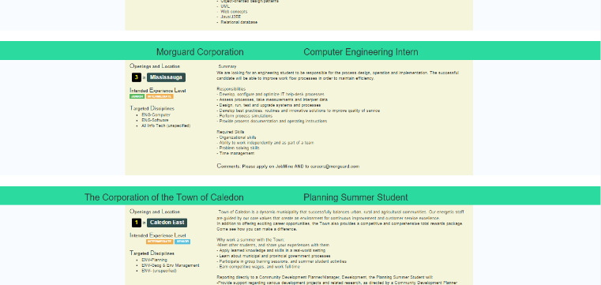Hi there! I ran into some issues when trying to set up the project (JobMine EZSearch) after forking it and if you haven’t used Python before, here are some steps for setting up. If you have, you can skip this document.

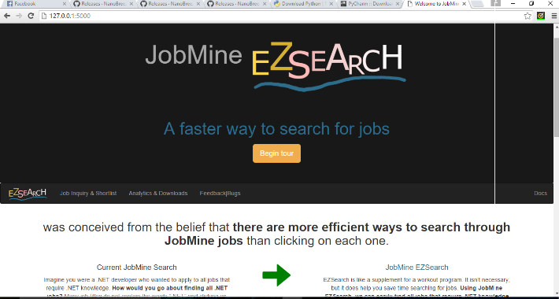

Hopefully, JobMine EZSearch can help you in your job search! One of the features that would likely help you is the “search by keywords”. Let’s say you’re looking to work with iOS, you can search for “iOS” in the keywords textbox and all jobs with “iOS” in the job summaries will appear. A prettier version of the original dump can also be downloaded for easier readability.

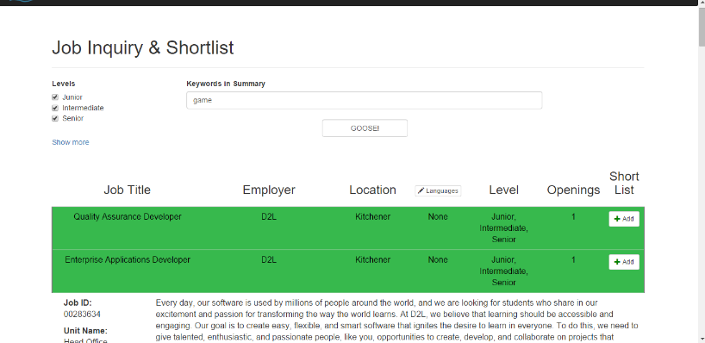**Step1:** Since JobMine EZSearch is a Python project, let’s download Python 3.5.1 from <https://www.python.org/downloads/>.On the first wizard path check the “Add Python to PATH” checkbox

**Step2:** Next, let’s download a Python IDE. Let’s use PyCharm:

<https://www.jetbrains.com/pycharm/download/#section=windows>

**Step3:** Open PyCharm and select

**Step 3.14:** You may need to install the requests library and bs4 library. To do this, type in cmd, pip install requests and then pip install bs4, pip install flask.

**Step 3.5:** Log into your JobMine account and make sure all the search filters in Job Inquiry are empty.

**Step4:** Run setup.py, remember to enter your username and password in the run console. These are stored in a local database and aren’t being snooped by mastermind. Your entered credentials stay only on your drive

**Step5:** Run Main.py and, if needed, set the Project Interpreter to the Python.exe file, double click the blue link in the Run window: http://127.0.0.1:portNumber/. Any time you want to open JobMine EZSearch, run Main.py.

Hope this helps! If you run into any troubles, let me know and I’ll make a video (Windows) to clarify any steps.